1. **Create a S3 bucket, with no public access and upload files to the bucket & view the logs using cloudwatch for the uploaded files.**

Step 01 - open the Amazon S3 console at Amazon S3 Console and, click on Create bucket.

S3 bucket created

Step 02 - In the S3 console, navigated to the newly created bucket (naresh33bucket).

And Click on Upload.

Step -04 – While I was still in my S3 bucket settings, I went to the Properties tab and Scroll down to find the Server access logging section the edited.

Step 05: Set Up CloudWatch Logs

Launch two ec2-instances and connect it to a application load balancer, where the output traffic from the server must be an load balancer IP address

Step 01 – Two EC2 Instances

Create Target Group

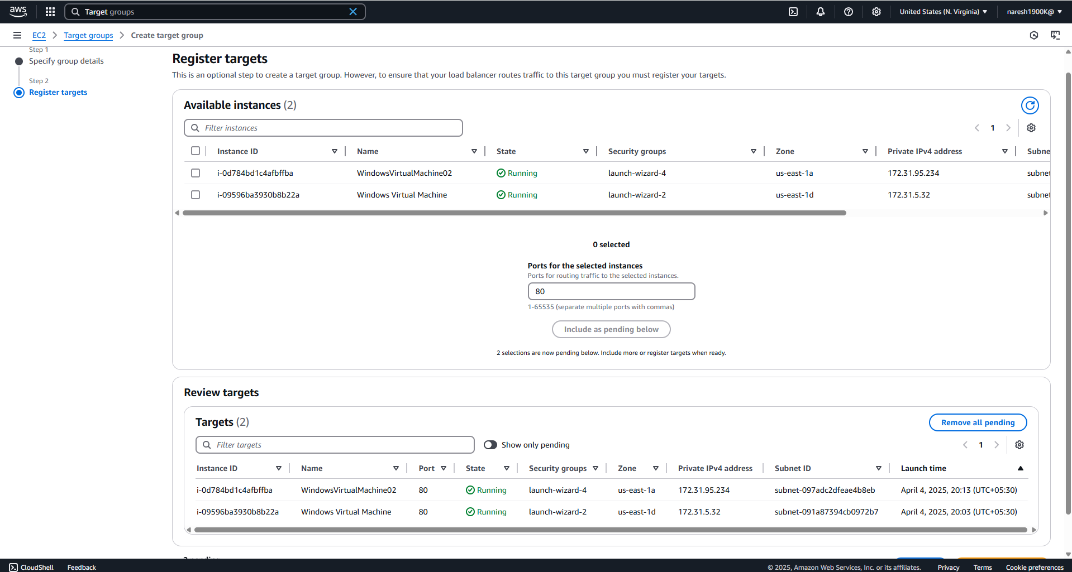

Step 02 – Create Load Balancer

